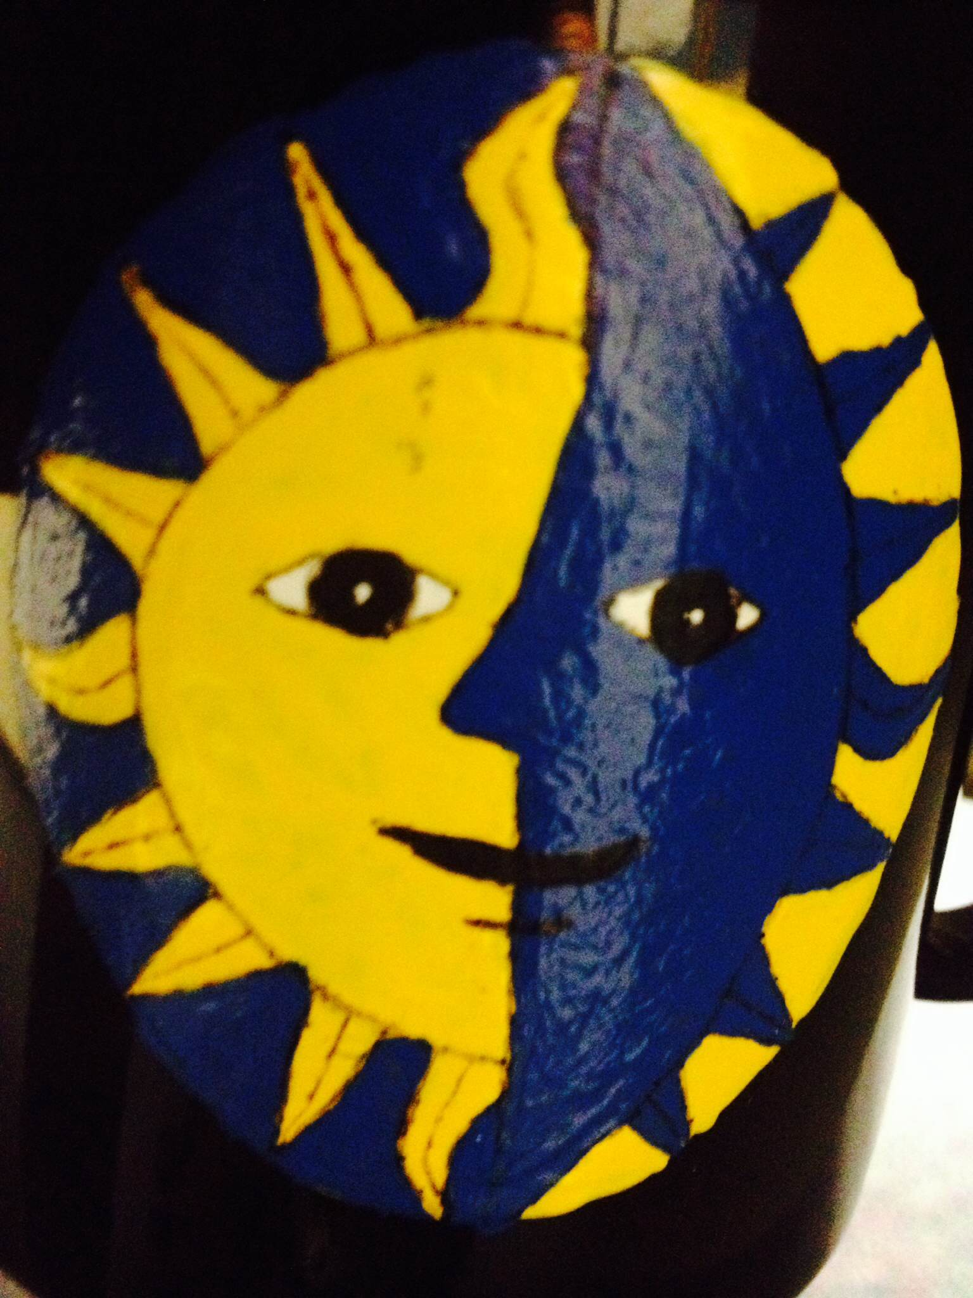

Eclipse Enquirer

www.wrmseclipse.weebly.com | October 12th, 2015

Reading Plus  by: Mrs. Cuper  Those students who wanted to retake the formative assessment (Flight of Icarus) had the opportunity to attend a reteach during my class today. They will need to complete the retake during EO this week. Tuesday we will prepare for the summative assessment which will be given Wednesday-Friday. The summative assessment assesses skills from both formatives taken this quarter. There will be NO RETAKING OPPORTUNITIES for the summative.  Extras  Confirmation slips for parent teacher conference are being sent home today.  If you still wish to schedule a conference contact Mr. McFarland at mcfarwil@usd437.net or call him at 339 4367. We still have some open time Thursday morning and afternoon.  Science  by: Mrs. Walters  Thanks to all the parents that helped us on the Konza field trip. It was a great day and I hope everyone had as much fun as I did!  It is the last week of the quarter. We are running out of time to take retakes and turn in late work. | Math  by: Mr. Pinnick  In math students are starting a new unit. See Mr. Pinnick’s website for more detailed information.  Important Dates  Oct. 13th - Kansas Test Ch 1  Oct. 13th- Author VIsit in LA  Oct. 14th- CEI Summative  Oct. 15th - End of Quarter  Oct. 21 & 22 - Conferences  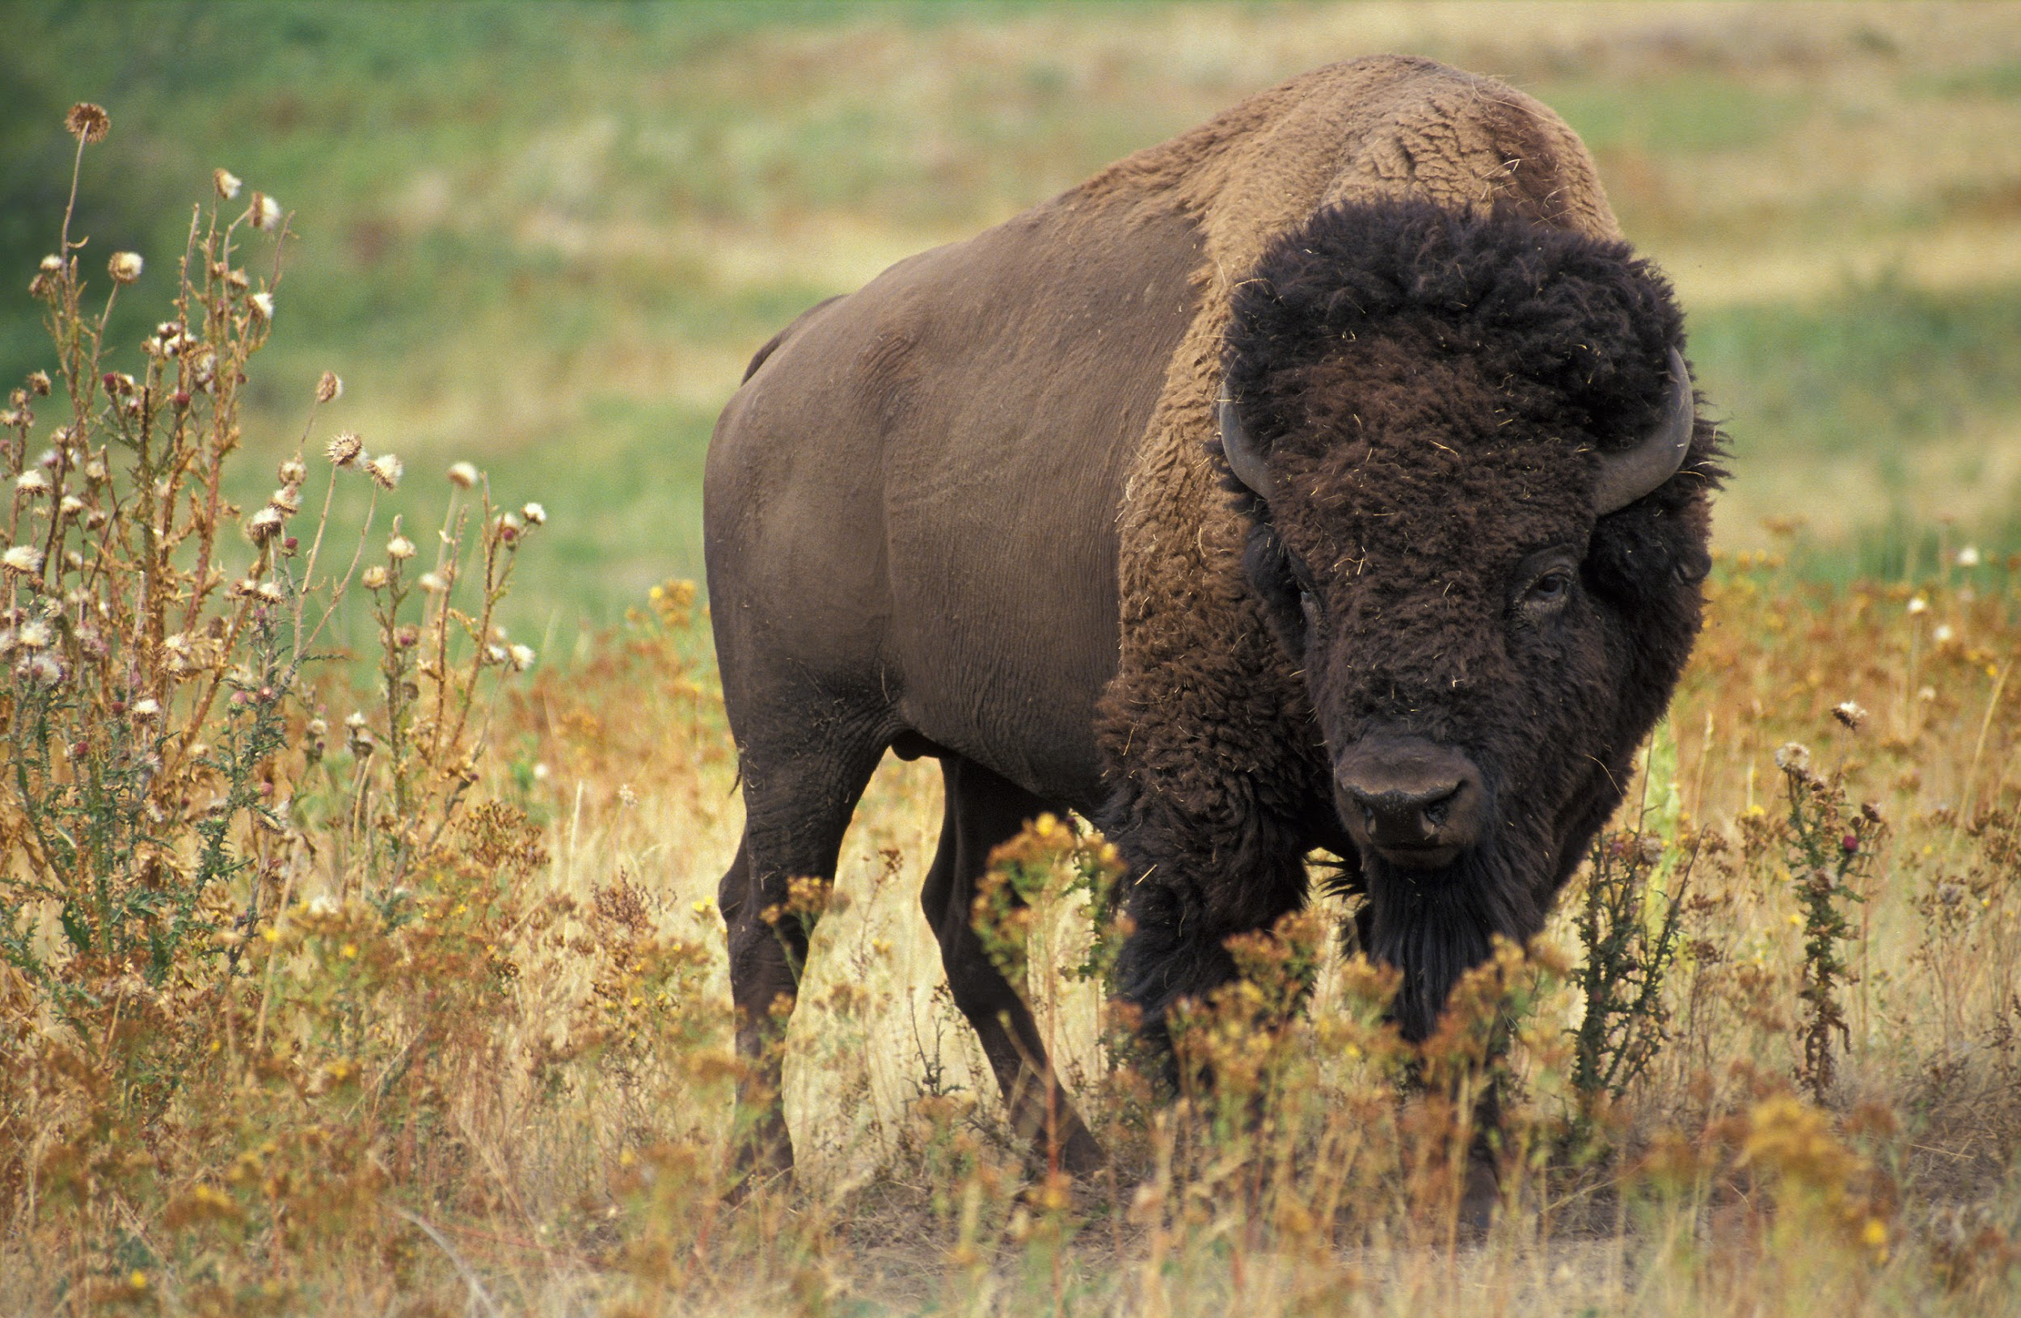 | Language Arts  by: Mrs. Schoenfeldt  Today we finished up the Narrative Summative Assessment. Any student who did not finish in class today is strongly encouraged to attend study hall after school tomorrow (Tuesday). This must be finished ASAP as the grade will be included on the 1st quarter report card. We will also be taking the CEI Summative Assessment this week, but that grade will go on 2nd quarter’s report card. This week we will also have a visit from local author Brian Reynolds! You can visit his website at www.brianreynoldswriting.com  Social Studies  by: Mr. McFarland  This week in Social Studies we will finish our study of Chapter 1 in our Kansas History book which covers the various regions and landforms of Kansas.  The test over this material is scheduled for this Tuesday, October 13th.  Check our website for pictures from the Konza field trip!

