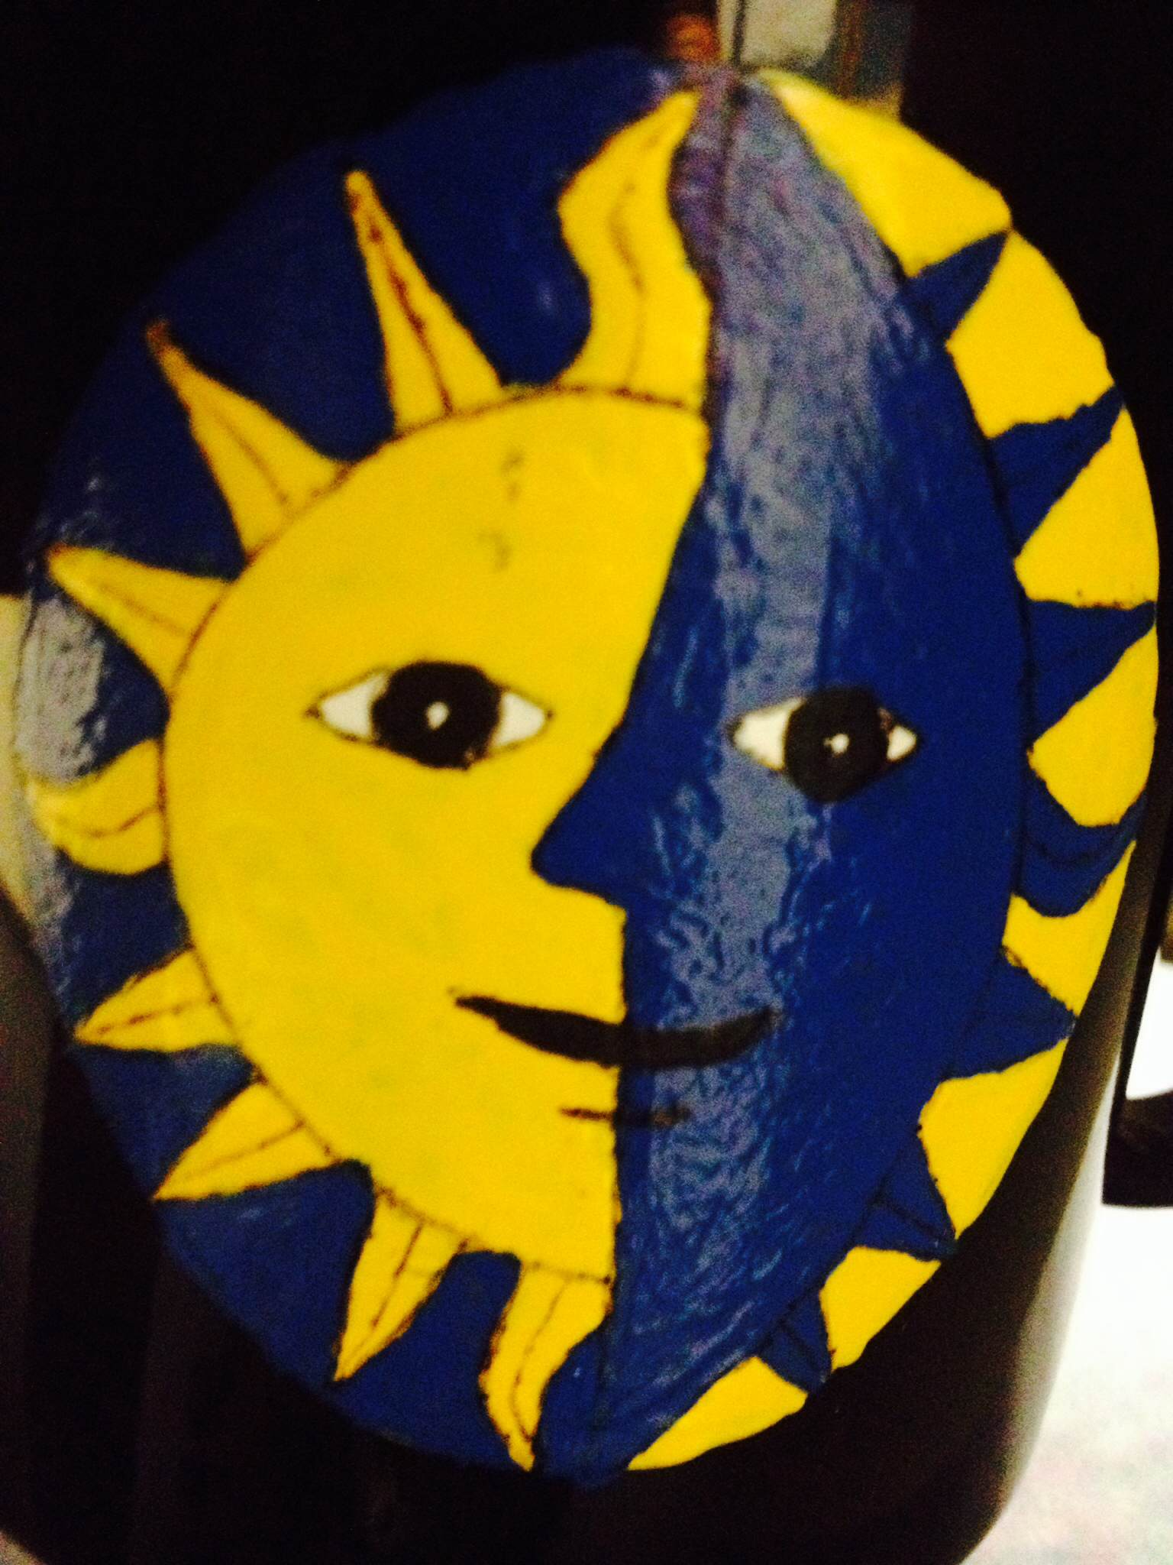

Eclipse Enquirer

www.wrmseclipse.weebly.com | October 5th, 2015

Reading Plus  by: Mrs. Cuper  This week we’ll be focusing on theme. We will identify the theme of the story we’ve been reading, Rogue Wave. The formative assessment will be given this week, assessing comprehension, inferencing, and elements of literature.  Extras  The KANZA Prairie field trip is this Thursday, October 8th. Before students are allowed to go on the field trip, a parent approval sheet must be signed and returned with a $1.  Parent Conference information went home in last week’s folder. Please return it ASAP. Time slots are filling up fast.  Science  by: Mrs. Walters  Thursday is our field trip to the Konza Prairie. Please dress for the weather and do not bring your phones!  I hope to have as much fun as we did when TJ “The Fishguy” came last week.!  Science News is due on Friday.  Science retakes on the Life Processes test must be done by October 14. | Math  by: Mr. Pinnick  The Unit 1 Test has been graded, all grades are submitted in Infinite Campus. If you scored below an 85% you will be spending Monday and Tuesday being re-taught. For those who scored above an 85% will be completing an enrichment activity. The Unit 1 Retake will be on Wednesday. Stay up to date on assignments by checking out www.mrpinnick.com.  Important Dates  Oct. 8th- KANZA Field Trip  Oct. 9th- Science News due  Oct. 13th - Kansas Test Ch 1  Oct. 15th - End of Quarter | Language Arts  by: Mrs. Schoenfeldt  This week we will begin the narrative writing summative assessment. This assessment will take about 4-5 days as students will complete all steps of the writing process. Rewrites of the CEI formative are due ASAP, and a rewrite opportunity will be provided in class for those who scored below 70% on last week’s narrative formative.  Social Studies  by: Mr. McFarland  This week in Social Studies we will finish our study of Chapter 1 in our Kansas History book which covers the various regions and landforms of Kansas.  The test over this material is scheduled for Tuesday, October 13th.  More Important Information on the back!
